Final Project
Annastasia Huang NetID:qingyuh2

Part 1
The three portfolios had mixed performance relative to the market's 26.14% return. While Portfolio C outperformed the market with superior stock selection, Portfolios A and B lagged despite similar market exposure.
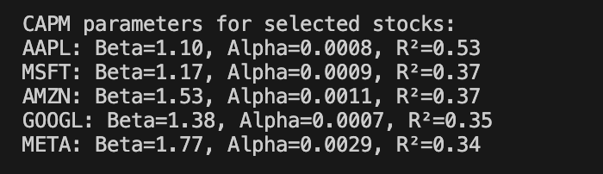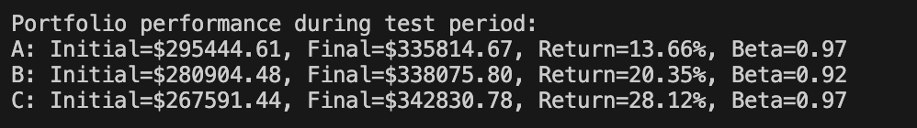
- All stocks show betas above 1, indicating higher volatility than the market
- R² values between 0.34-0.53 suggest CAPM explains only one-third to one-half of each stock's return variability
- All stocks exhibited positive alpha during the training period
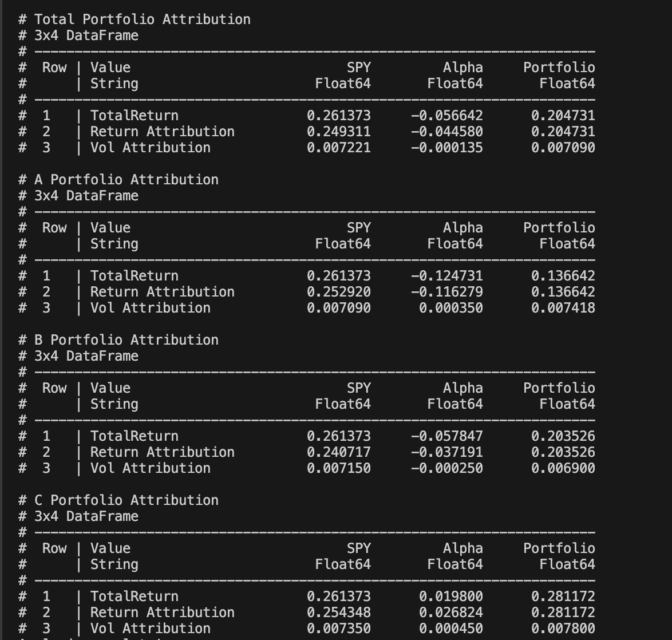
In Part 1, I used SPY as the market proxy and ran a CAPM regression on each stock’s daily excess returns through December 29, 2023. The fitted betas show that the tech names tended to move more than the market—AAPL at 1.10, MSFT at 1.17, AMZN at 1.53, GOOGL at 1.38 and META at 1.77—while R² values around 0.35–0.53 tell us that a large share of each stock’s swings comes from idiosyncratic factors.
When I applied those betas to the actual holding‐period returns (through spring 2025), the total portfolio returned 20.47%. The CAPM systematic contribution—beta times SPY’s 26.14% gain—was 24.93%, but the total came in lower because idiosyncratic returns dragged the portfolio down by –4.46%. In other words, the group of stocks moved in line with the market to earn nearly 25%, but stock‐specific moves wiped out about four and a half points. Volatility attribution echoes that story: systematic risk accounted for virtually all of the total 0.709% daily volatility, while idiosyncratic risk shaved off just –0.0135% of that number.
Breaking it into sub‐portfolios, A underperformed the market by a wide margin. Its beta of 0.97 implied a 25.29% systematic return, but the actual 13.66% outcome left an idiosyncratic hole of –11.63%. Portfolio B fared slightly better: its 0.92 beta implied 24.07% market exposure, yet it only gained 20.35%, so its stock‐specific returns were –3.72%. By contrast, Portfolio C outperformed its 0.97 beta (25.43% systematic) by delivering a total of 28.12%, so idiosyncratic added +2.68%.

Part 2
In Part 2, I constructed optimal portfolios for each portfolio (A, B, and C) by maximizing the Sharpe ratio, which optimizes the risk-return tradeoff. This optimization used the CAPM parameters from Part 1 but assumed zero alpha and used historical averages for expected market return and risk-free rate.
Expected Annual Returns for Major Stocks:
- AAPL: 26.88%
- MSFT: 28.19%
- AMZN: 35.39%
- GOOGL: 32.34%
- META: 40.03%
Optimal Portfolio Characteristics:
Portfolio | Expected Return | Expected Volatility | Sharpe Ratio
A | 25.03% | 13.71% | 1.46
B | 24.96% | 13.47% | 1.48
C | 25.17% | 13.62% | 1.48
Total | 25.05% | 13.60% | 1.48

All optimal portfolios had about 25% return and 13.5% risk, so they all gave a Sharpe of about 1.48.

Total Portfolio Performance:
Metric | Original Portfolio | Optimal Portfolio | Difference
Total Return | 20.47% | 28.39% | +7.91%
Systematic Return | 24.93% | 26.44% | +1.51%
Idiosyncratic Return | -4.46% | +1.95% | +6.41%
Portfolio Beta | 0.95 | 1.01 | +0.06
Sharpe Ratio | N/A | 1.48 | N/A

Portfolio Performance:
Portfolio | Metric | Original | Optimal | Difference
A | Total Return | 13.66% | 28.86% | +15.20%
 | Systematic Return | 25.29% | 26.41% | +1.12%
 | Idiosyncratic Return | -11.63% | +2.45% | +14.07%
 | Portfolio Beta | 0.97 | 1.01 | +0.04
 | Sharpe Ratio | N/A | 1.46 | N/A
B | Total Return | 20.35% | 25.79% | +5.44%
 | Systematic Return | 24.07% | 26.32% | +2.24%
 | Idiosyncratic Return | -3.72% | -0.53% | +3.19%
 | Portfolio Beta | 0.92 | 1.01 | +0.09
 | Sharpe Ratio | N/A | 1.48 | N/A
C | Total Return | 28.12% | 30.59% | +2.47%
 | Systematic Return | 25.43% | 26.59% | +1.16%
 | Idiosyncratic Return | +2.68% | +4.00% | +1.32%
 | Portfolio Beta | 0.97 | 1.02 | +0.04
 | Sharpe Ratio | N/A | 1.48 | N/A
- Portfolio A’s return rose from 13.66% to 28.86% (+15.20%). This jump is from the idio part going from –11.63% to 2.45%. That shows the original A had bad stock picks, but the new A did better even with alpha set to zero.
- All optimal portfolios have betas near 1.01 but the originals were 0.92–0.97, so more market exposure helped the Sharpe ratio.
- The Sharpe-based mix moved weight away from stocks with big idio risk and to ones with better risk-adjusted returns.

Part 3
First, the Normal Inverse Gaussian (NIG) distribution mixes a normal variance-mean law with an inverse Gaussian law and has four parameters that shape its tail weight, skew, scale, and location. It can show heavier tails than the normal law and handle both skewness and excess kurtosis, and it stays valid when you add returns over different time spans. Because it has a closed-form characteristic function, we use it to build option pricing models that capture large jumps in asset prices.
Next, the Skew Normal distribution adds one shape parameter to the normal law while keeping its location and scale settings, so it can lean left or right but still look like a bell curve. When the shape is zero, it becomes the normal law. It has clear formulas for its density and moments, and we can generate random samples from it easily in code, which helps us model mild asymmetry in financial data.
Also, for modeling asset returns, markets often show extreme moves and tilt that the normal law misses. Using NIG lets us fit fat tails and capture rare, large gains or losses, and using Skew Normal lets us fit a small lean in either direction. Fitting these laws to daily return data shows they match the real return distribution better than the normal law.
Then, for risk management, we compute Value-at-Risk and Expected Shortfall under each law instead of using the normal law. When we fit NIG or Skew Normal, the VaR and ES numbers rise in stressed markets because fat tails or skew push more weight into the extremes. This gives more realistic estimates of how much we can lose on bad days.
Next, for option pricing, we use the NIG distribution inside Lévy process models so that option prices can show the volatility smile and skew we see in market quotes. We plug its characteristic function into pricing formulas. We can also use Skew Normal under the risk-neutral measure to tilt the price density and adjust call and put prices for the skew premium.
Also, for portfolio optimization, the classic mean-variance method only looks at average return and variance. If we build a model with NIG or Skew Normal, we add skewness and kurtosis preferences and can choose weights that avoid heavy tails or match investor bias. In a multivariate setting, these laws help capture tail dependence when assets tend to crash together.
In this class, we used Python to fit NIG and Skew Normal by maximum likelihood and then we plotted their pdfs versus the normal law. We saw how idiosyncratic returns from Parts 1 and 2 had skew and fat tails, and we recalculated VaR and ES with these laws. That practice showed us how non-normal distributions can reduce model risk and improve our risk attribution and portfolio results.

Part 4
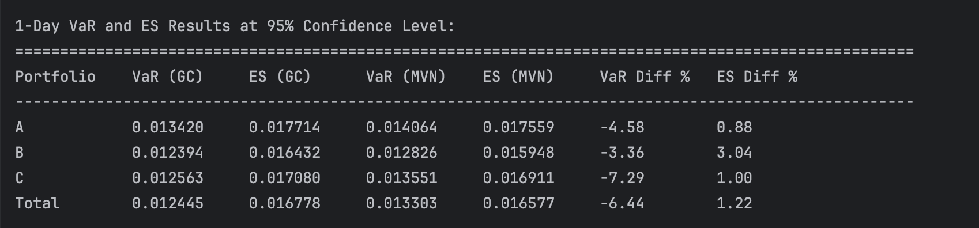
Summary of Best Fitted Distributions:
================================================================================
Symbol Best Model Parameters AIC BIC
--------------------------------------------------------------------------------
SPY Normal (np.float64(0.000984995968857643... -1679.7372 -1672.7023
AAPL GeneralizedT (np.float64(7.327051838491508), ... -1476.9263 -1466.3740
NVDA GeneralizedT (np.float64(4.7894259335685145),... -1086.8051 -1076.2528
MSFT GeneralizedT (np.float64(7.771869491862947), ... -1361.0912 -1350.5389
AMZN GeneralizedT (np.float64(5.921858678408782), ... -1232.2503 -1221.6980
META GeneralizedT (np.float64(4.219603763694025), ... -1232.5420 -1221.9897
GOOGL GeneralizedT (np.float64(4.420042577129786), ... -1288.6210 -1278.0687
AVGO GeneralizedT (np.float64(4.301679167226009), ... -1267.4773 -1256.9250
TSLA GeneralizedT (np.float64(6.491179532324071), ... -992.0883 -981.5359
GOOG GeneralizedT (np.float64(4.593602737714918), ... -1283.0645 -1272.5121
BRK-B GeneralizedT (np.float64(6.7452469646759425),... -1665.2640 -1654.7116
JPM GeneralizedT (np.float64(3.5188069243646165),... -1492.3959 -1481.8435
LLY GeneralizedT (np.float64(3.2335881680585863),... -1359.9131 -1349.3608
V GeneralizedT (np.float64(9.519656627518527), ... -1594.6753 -1584.1229
XOM GeneralizedT (np.float64(7.88072967197931), n... -1364.0375 -1353.4852
UNH GeneralizedT (np.float64(3.371018433820346), ... -1495.4633 -1484.9110
MA GeneralizedT (np.float64(6.468192091737563), ... -1559.7485 -1549.1962
COST GeneralizedT (np.float64(4.621162605708779), ... -1519.0883 -1508.5360
PG GeneralizedT (np.float64(5.519839122112227), ... -1625.1328 -1614.5804
WMT GeneralizedT (np.float64(6.0450672562458365),... -1643.4735 -1632.9211
HD GeneralizedT (np.float64(4.5350878496136495),... -1455.5225 -1444.9701
NFLX GeneralizedT (np.float64(3.644841361650238), ... -1213.5910 -1203.0386
JNJ GeneralizedT (np.float64(3.6050382592772507),... -1612.0728 -1601.5204
ABBV GeneralizedT (np.float64(4.019556093102607), ... -1522.5965 -1512.0441
CRM GeneralizedT (np.float64(5.107222552534822), ... -1307.1806 -1296.6283
BAC GeneralizedT (np.float64(4.267520787637019), ... -1338.3414 -1327.7890
ORCL GeneralizedT (np.float64(3.081850436424118), ... -1369.4416 -1358.8892
MRK GeneralizedT (np.float64(8.068428120841219), ... -1501.3811 -1490.8287
CVX GeneralizedT (np.float64(4.553447312724085), ... -1418.6456 -1408.0932
KO GeneralizedT (np.float64(5.2154807174783775),... -1690.4399 -1679.8875
CSCO GeneralizedT (np.float64(3.8949338341651574),... -1528.5820 -1518.0296
WFC GeneralizedT (np.float64(5.003669059840126), ... -1320.4719 -1309.9196
ACN GeneralizedT (np.float64(6.97220211577009), n... -1436.7430 -1426.1906
NOW GeneralizedT (np.float64(3.9504261084847876),... -1255.0302 -1244.4779
MCD GeneralizedT (np.float64(10.042770483140238),... -1648.3481 -1637.7957
PEP GeneralizedT (np.float64(5.804994721603205), ... -1627.7076 -1617.1552
IBM GeneralizedT (np.float64(4.815192412828923), ... -1610.0899 -1599.5376
DIS GeneralizedT (np.float64(4.908405400049021), ... -1351.3903 -1340.8379
TMO GeneralizedT (np.float64(5.160945422659916), ... -1415.8711 -1405.3187
LIN GeneralizedT (np.float64(3.172833729496785), ... -1507.0656 -1496.5132
ABT GeneralizedT (np.float64(6.227416030940623), ... -1500.4155 -1489.8631
AMD GeneralizedT (np.float64(4.697518773422056), ... -1062.8431 -1052.2908
ADBE GeneralizedT (np.float64(5.878008004417815), ... -1247.8038 -1237.2514
PM GeneralizedT (np.float64(8.156221501601319), ... -1570.1379 -1559.5856
ISRG GeneralizedT (np.float64(4.700215566441738), ... -1311.5888 -1301.0364
GE SkewNormal (np.float64(1.8224923433425446),... -1380.8351 -1370.2827
GS GeneralizedT (np.float64(5.505642894982417), ... -1387.5365 -1376.9841
INTU GeneralizedT (np.float64(5.5701179139319805),... -1290.8660 -1280.3136
CAT GeneralizedT (np.float64(4.450136312290146), ... -1325.1094 -1314.5570
QCOM GeneralizedT (np.float64(5.220655002485377), ... -1259.5196 -1248.9673
TXN GeneralizedT (np.float64(9.150954622844177), ... -1380.5787 -1370.0263
VZ GeneralizedT (np.float64(3.271241480506749), ... -1466.0339 -1455.4815
AXP GeneralizedT (np.float64(4.718568095222283), ... -1367.1578 -1356.6054
T GeneralizedT (np.float64(3.021497621326153), ... -1403.5698 -1393.0174
BKNG GeneralizedT (np.float64(8.120433832888796), ... -1367.0186 -1356.4663
SPGI GeneralizedT (np.float64(4.164962558687011), ... -1458.8754 -1448.3231
MS GeneralizedT (np.float64(4.49436034621783), n... -1362.6075 -1352.0552
RTX GeneralizedT (np.float64(3.208685947734061), ... -1463.3025 -1452.7501
PLTR GeneralizedT (np.float64(3.1103275293944916),... -901.2430 -890.6906
PFE GeneralizedT (np.float64(4.092582810677552), ... -1425.2011 -1414.6488
BLK GeneralizedT (np.float64(7.9336860540847045),... -1423.7598 -1413.2074
DHR GeneralizedT (np.float64(5.305481750132705), ... -1395.2150 -1384.6627
NEE GeneralizedT (np.float64(2.9511778671913897),... -1368.6339 -1358.0815
HON GeneralizedT (np.float64(5.729085945858001), ... -1526.5872 -1516.0349
CMCSA GeneralizedT (np.float64(4.556057592231218), ... -1436.2221 -1425.6697
PGR GeneralizedT (np.float64(2.6467674293677947),... -1382.5968 -1372.0444
LOW NIG (np.float64(63.63379062627206), ... -1404.1570 -1390.0872
AMGN GeneralizedT (np.float64(5.944480294623073), ... -1458.3092 -1447.7568
UNP GeneralizedT (np.float64(3.9852630125121564),... -1452.5710 -1442.0187
TJX GeneralizedT (np.float64(10.191802212228234),... -1582.0694 -1571.5171
AMAT SkewNormal (np.float64(1.4054197773746195),... -1207.8378 -1197.2854
UBER GeneralizedT (np.float64(9.440553417754458), ... -1179.0636 -1168.5112
C GeneralizedT (np.float64(4.168034424926221), ... -1370.8899 -1360.3376
BSX GeneralizedT (np.float64(3.5408599973299513),... -1504.2783 -1493.7259
ETN GeneralizedT (np.float64(3.8783439019450565),... -1353.6778 -1343.1254
COP GeneralizedT (np.float64(5.830128203718905), ... -1307.3611 -1296.8088
BA GeneralizedT (np.float64(4.703007872721208), ... -1335.8107 -1325.2583
BX GeneralizedT (np.float64(6.30593330386122), n... -1200.5003 -1189.9479
SYK GeneralizedT (np.float64(2.663109184303306), ... -1451.4338 -1440.8815
PANW GeneralizedT (np.float64(3.3221452095328576),... -1201.9118 -1191.3594
ADP GeneralizedT (np.float64(3.3902668413539083),... -1505.2253 -1494.6730
FI GeneralizedT (np.float64(3.721627851559792), ... -1500.1683 -1489.6159
ANET GeneralizedT (np.float64(2.744064008994597), ... -1166.4653 -1155.9130
GILD GeneralizedT (np.float64(8.569309439426583), ... -1464.3701 -1453.8177
BMY GeneralizedT (np.float64(4.359798987487753), ... -1510.0344 -1499.4820
SCHW GeneralizedT (np.float64(2.8391353832455217),... -1164.1639 -1153.6115
TMUS GeneralizedT (np.float64(5.569307566177855), ... -1511.6652 -1501.1129
DE GeneralizedT (np.float64(5.60072370060907), n... -1331.7323 -1321.1800
ADI GeneralizedT (np.float64(6.363938081716805), ... -1348.8319 -1338.2796
VRTX GeneralizedT (np.float64(4.006971289299858), ... -1429.6126 -1419.0602
SBUX GeneralizedT (np.float64(4.1893860774906155),... -1475.6237 -1465.0713
MMC GeneralizedT (np.float64(5.360674635007793), ... -1575.0405 -1564.4882
MDT GeneralizedT (np.float64(4.582971886225369), ... -1448.8119 -1438.2595
CB GeneralizedT (np.float64(5.691796533812839), ... -1473.9467 -1463.3944
LMT GeneralizedT (np.float64(3.703324783347372), ... -1589.4067 -1578.8543
KKR GeneralizedT (np.float64(7.228193610201442), ... -1244.8947 -1234.3423
MU SkewNormal (np.float64(2.2150280256287953),... -1189.3010 -1178.7486
PLD GeneralizedT (np.float64(6.6757024571936014),... -1338.0347 -1327.4823
LRCX GeneralizedT (np.float64(4.955105258330859), ... -1182.1052 -1171.5528
EQIX GeneralizedT (np.float64(5.295939280117), np.... -1383.3625 -1372.8101

----------------------------------------------------------------

Discussion on Question 4
Most stocks (95%) fit the Student’s t distribution best and only a few fit the NIG or Skew Normal laws. SPY was the only one that matched the normal law, while LOW matched NIG and GE, AMAT, MU matched Skew Normal. This shows that most returns have fat tails rather than being perfectly normal.
When we compared one-day VaR and ES at 95%, the Gaussian Copula (GC) method gave slightly lower VaR for all portfolios (A: –4.6%, B: –3.4%, C: –7.3%, Total: –6.4%) but slightly higher ES for A and C (A: +0.9%, C: +1.0%) and lower ES for B (–3.0%). That means GC usually lowers the loss at the VaR cutoff but can raise or lower the expected loss beyond that cutoff.
The differences arise because GC uses each stock’s best-fit marginal law and then glues them with a normal copula. This lets each margin keep its fat tails or skew and also lets tail events co-occur more or less often depending on the data. In contrast, the multivariate normal (MVN) forces all margins to be normal and ties them together only by linear correlation, so it can miss joint extremes when returns are heavy-tailed or skewed.
Because most stocks showed excess kurtosis, the GC approach down-weights extreme joint moves in VaR but up-weights them in ES when tails matter more. The MVN approach tends to spread risk evenly across days, so it can overestimate VaR for portfolios that mix heavy-tailed and light-tailed assets, and it can underestimate ES if the true tails are fatter than normal.
In practice, using the Gaussian Copula gave more realistic estimates of tail risk for our portfolios because it kept each stock’s real distribution shape. The multivariate normal gave simpler risk numbers but it could misstate how likely joint losses are when markets move together in extremes.
This comparison shows that choosing the right marginal laws and dependence model matters. If we assume normality, we may get VaR and ES that look close but hide real tail risk. If we fit and simulate with GC, we see how non-normality and tail dependence change the risk measures.
Overall, the small VaR differences but mixed ES differences here suggest that our portfolios are not highly sensitive to the copula choice under normal market conditions, but they would be in a stress scenario. That makes the GC approach a better tool for stress testing and for meeting stricter risk controls.

Part 5

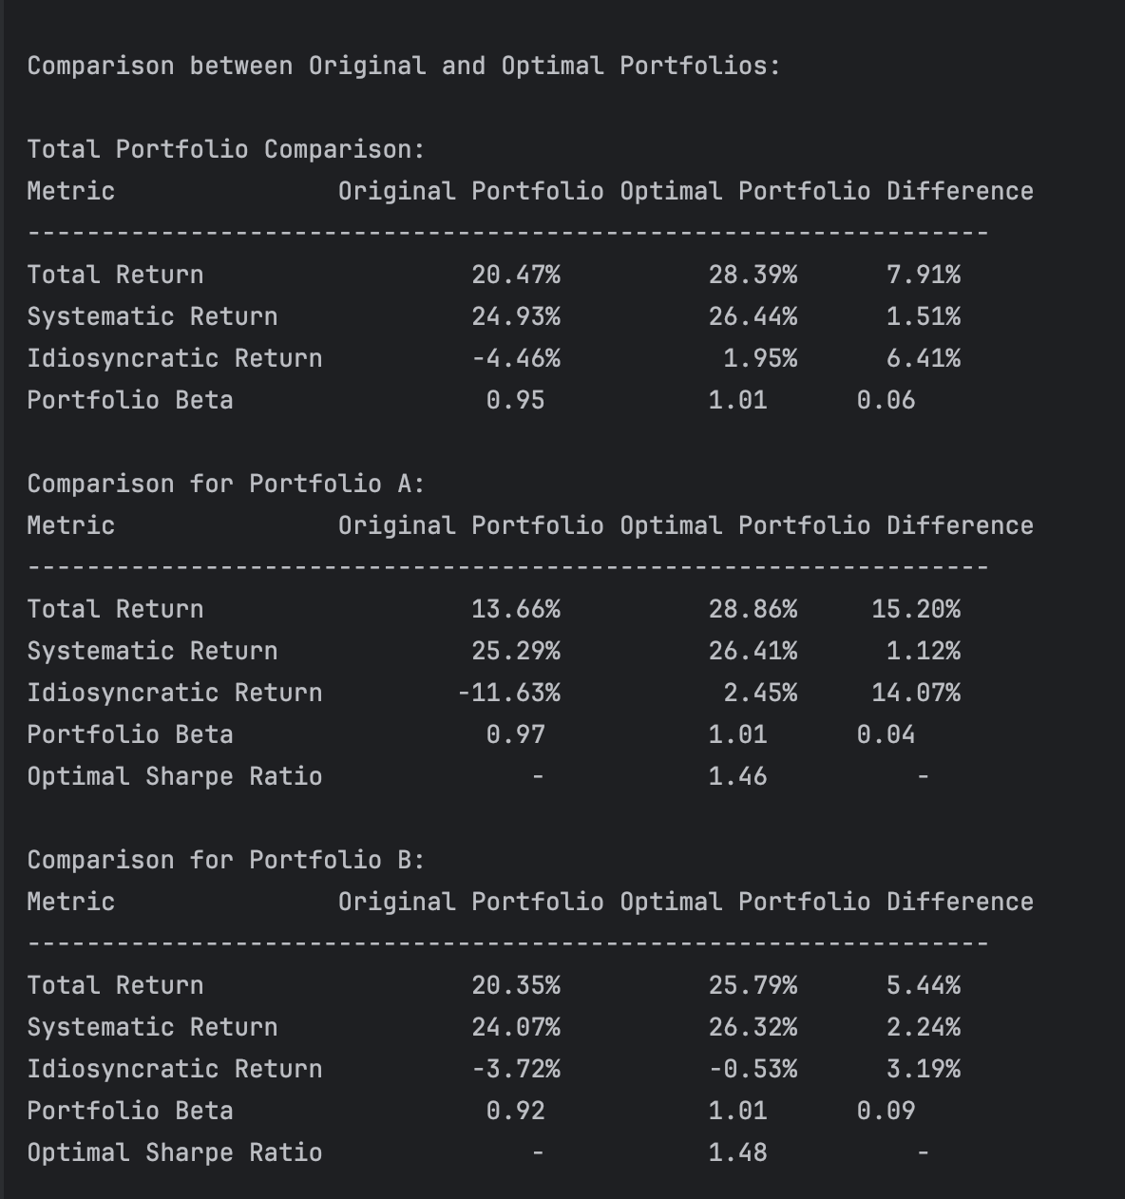

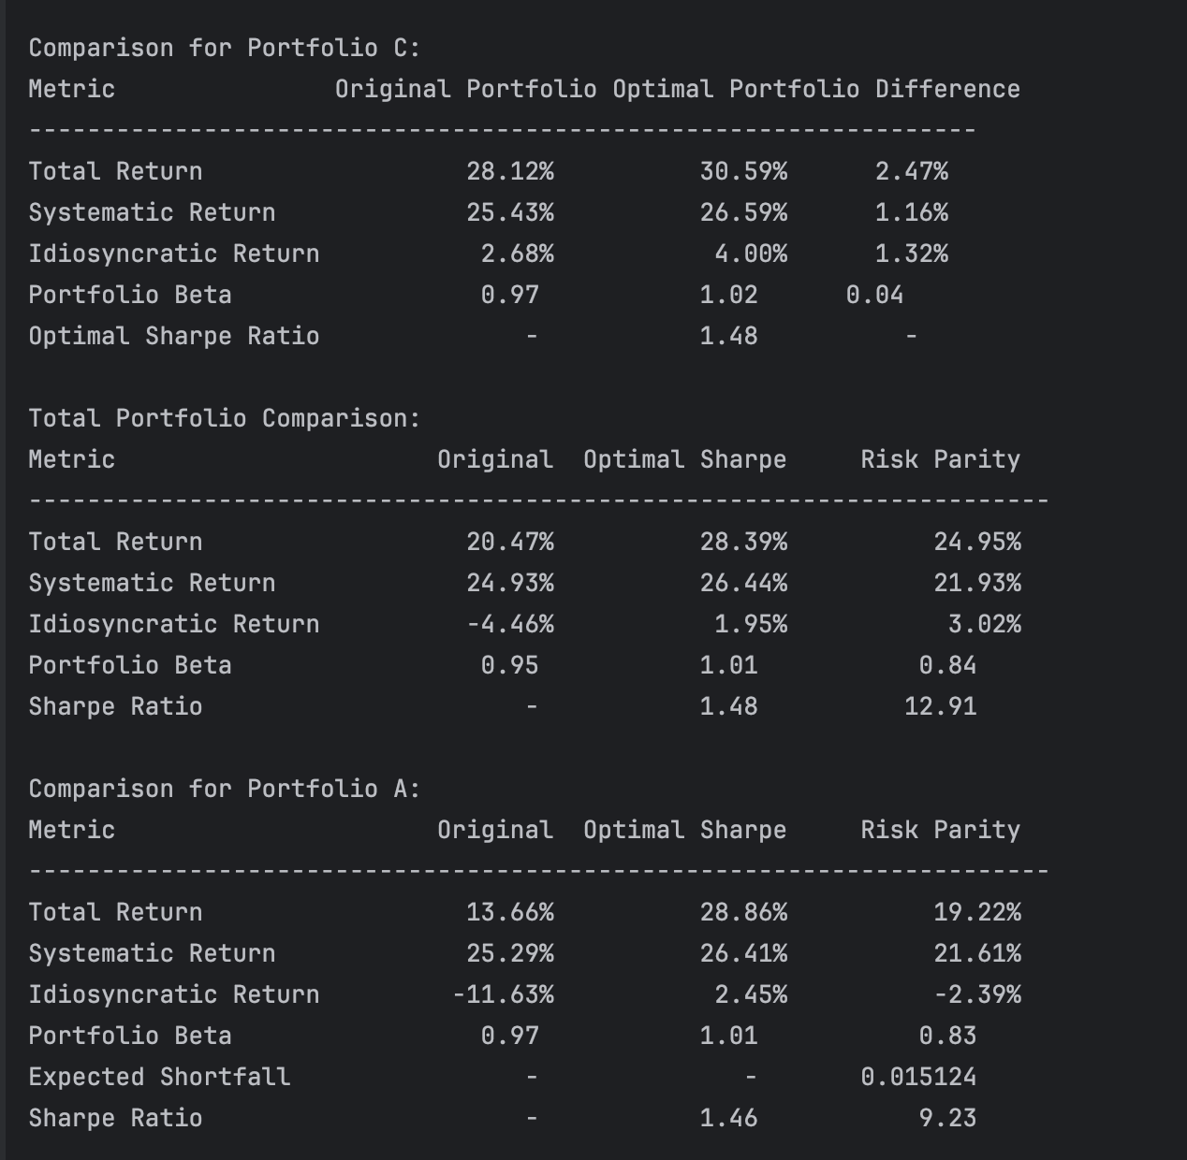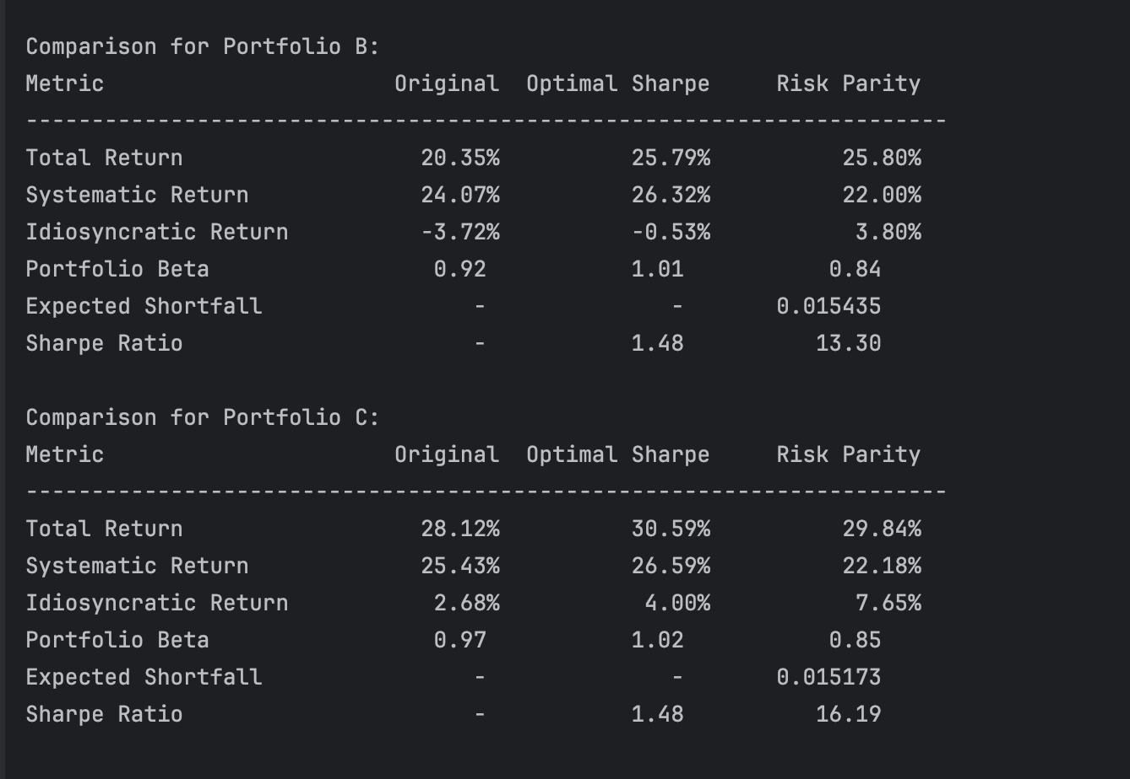
Using the fitted marginal laws and the Gaussian Copula, I built ES‐based risk parity portfolios for A, B, and C. Then I ran CAPM attribution with the same betas from Part 1. Here is how they compare to the original weights (Part 1) and the Sharpe‐optimal weights (Part 2).
First, looking at the total portfolio, the original weights from Part 1 returned 20.47% with a systematic contribution of 24.93% and an idiosyncratic drag of –4.46% (beta 0.95). When we shifted to the Sharpe‐optimal weights in Part 2, total return jumped to 28.39% with a systematic return of 26.44% and idiosyncratic gain of 1.95% (beta 1.01). The ES‐based risk parity portfolio lands in between: it delivered 24.95% total return, 21.93% systematic, and 3.02% idiosyncratic (beta 0.84). In other words, risk parity gives up some market return versus the Sharpe mix but turns the large negative stock‐specific losses in Part 1 into a positive idiosyncratic contribution, all while lowering overall market exposure.
Turning to Portfolio A, the original CAPM attribution showed a modest 13.66% return driven by 25.29% systematic offset by –11.63% idiosyncratic (beta 0.97). The Sharpe‐optimal version captured 28.86%, with 26.41% market and +2.45% stock‐specific gains (beta 1.01). Under risk parity, A returned 19.22%, with 21.61% systematic and –2.39% idiosyncratic (beta 0.83). This means risk parity recovers most of the idiosyncratic loss seen in Part 1—shrinking it from –11.63% to –2.39%—and reduces beta, though at the cost of some market return compared to the Sharpe portfolio.
For Portfolio B, the original holdings returned 20.35% (24.07% market, –3.72% idiosyncratic, beta 0.92). The Sharpe‐optimal mix improved that to 25.79% (26.32% and –0.53%, beta 1.01). Risk parity matched the Sharpe return at 25.80% but with only 22.00% systematic and +3.80% idiosyncratic (beta 0.84). In effect, ES‐based risk parity preserved the high total return of the Sharpe portfolio while cutting market exposure and flipping a small negative idiosyncratic outcome into a strong positive.
Finally, Portfolio C originally returned 28.12% (25.43% systematic, +2.68% idiosyncratic, beta 0.97). The Sharpe mix nudged that to 30.59% (26.59% and +4.00%, beta 1.02). Risk parity achieved 29.84%, with 22.18% market and +7.65% stock‐specific gains (beta 0.85). Thus it nearly matches the Sharpe return, materially lowers beta, and more than doubles the idiosyncratic gain versus the original.
Overall, rerunning the Part 1 CAPM attribution on ES‐based risk parity portfolios shows a consistent pattern: idiosyncratic contributions move from large negatives in the original to modest or substantial positives, and betas fall below both original and Sharpe‐optimal levels. Compared to Part 1, risk parity turns drag into alpha and reduces market risk. Compared to Part 2, it trades some systematic upside for much stronger control of tail risk and higher stock‐specific returns, making the allocations more robust to extreme events.

